**Title: digital marketing**

Comprehensive digital marketing for haldiram 's

horizontal line

# 

# Introduction

Comprehensive digital marketing for haldiram 's

Haldiram's, a renowned Indian sweets and snacks brand, aims to strengthen its online presence, increase brand awareness, and drive sales through a robust digital marketing strategy. This plan outlines a 360-degree approach to leverage various digital channels, enhance customer engagement, and reinforce Haldiram's position as a leader in the Indian food industry

# Brand Study, Competitor Analysis & Buyer's/Audience's Persona

## 

## 

## Rearch brand identity

1. Brand Core Identity

a) Brand Purpose (Why We ExistTo bring the authentic taste of Indian tradition to every corner of the world while adapting to modern preferences and lifestyles.

b) Brand Vision

To be the global leader in Indian snacks and ready-to-eat foods, blending tradition with innovation.

c) Brand Mission

To offer high-quality, authentic Indian snacks using premium ingredients.To evolve with customer preferences while retaining the essence of Indian flavors.To create a cultural connection through food and tradition.

d) Brand Values

✅ Authenticity – Staying true to traditional Indian recipes and flavors.

✅ Quality – Using the finest ingredients and maintaining high production standards.

✅ Innovation – Introducing new flavors and healthier options.

✅ Inclusivity – Offering products for diverse dietary needs and global tastes.

✅ Sustainability – Environmentally conscious sourcing and packaging.

Brand Study

This involves understanding Haldiram’s as a brand, including its market positioning, values, and unique selling points (USPs). Key areas to cover:

Brand History – Origin, growth, and key milestones.

Mission and Vision – Core purpose and long-term goals.

Product Portfolio – Range of snacks and sweets offered.

Brand Identity – Logo, tagline, packaging, and overall brand aesthetic.

Market Positioning – How Haldiram’s is perceived in the market (e.g., premium, affordable, traditional).

Strengths and Weaknesses – Internal factors influencing performance.

## Competitor analysis

For a competitor analysis for Haldiram’s, you'd want to focus on understanding the competitive landscape in the **snack and packaged food industry**. Here’s a structured approach to conducting a comprehensive competitor analysis:

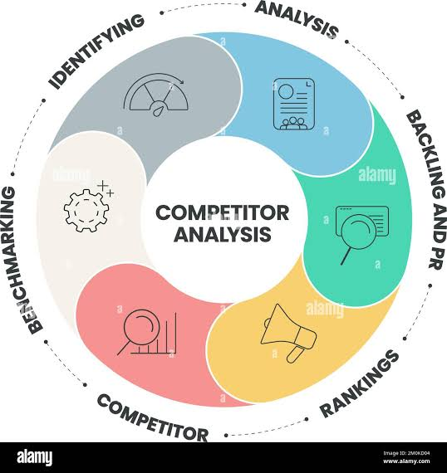

## 1. Identify Key Competitors

Start by identifying both **direct** and **indirect** competitors:

* **Direct competitors** – Other Indian snack brands and packaged food companies (e.g., Bikaji, Balaji, Bikanervala, Lays).
* **Indirect competitors** – Brands offering alternative snack options (e.g., Britannia, Parle, PepsiCo).

## 2. Analyze Competitor Offerings

Evaluate competitors’ product portfolios:

* **Product Range** – Types of snacks (e.g., namkeens, sweets, frozen foods).
* **Pricing Strategy** – Competitive pricing models, discounts, bundling.
* **Quality and Packaging** – Product quality, shelf life, and packaging design.

## 3. Market Positioning

Assess how competitors are positioning themselves:

* **Brand messaging** – Health-focused, traditional, premium, etc.
* **Target audience** – Age groups, income levels, geographic focus.
* **Market share** – Competitor’s market penetration and growth.

## 4. Marketing and Promotion Strategies

## Study their approach to marketing:

* **Content Strategy** – Social media, influencer partnerships, traditional advertising.
* **SEO and Digital Presence** – Website optimization, search rankings, PPC campaigns.

**Engagement Metrics** – Social media following, engagement rates, and customer feedback.

## 5. Distribution and Sales Channels

Understand how competitors are reaching customers:

* **Retail presence** – Supermarkets, convenience stores, e-commerce platforms.
* **Online channels** – Brand website, Amazon, Blinkit, Zomato, etc.
* **Geographic reach** – Domestic and international markets.

# these are competitors for haldiram 's

## Competitor 1: Bikaji

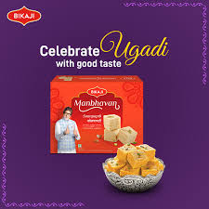

✅ USP (Unique Selling Proposition):Strong focus on traditional Indian flavors and recipes.

Wide product range including bhujia, namkeens, and sweets.

Strong presence in both domestic and international markets.

## 🌐 Online Communication:

Active on Instagram, Facebook, and YouTube with recipe ideas and festive-themed posts.

Emphasis on tradition and authenticity in visuals and messaging.

Uses influencer marketing and seasonal campaigns to drive engagement.

# Competitor 2: Balaji Wafers

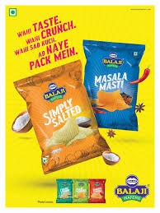

✅ USP:Competitive pricing with a focus on value-for-money products.

Strong market presence in Western and Central India.

Known for potato chips and regional flavors.

## 🌐 Online Communication:

Focus on relatable, everyday snackingmoments.

Regular posts on Instagram and Facebook featuring user-generated content.

Highlights affordability and taste as core value propositions.

## Competitor 3: Bikanervala

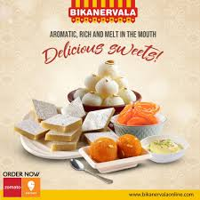

✅ USP:Premium positioning with a focus on sweets and festive snacks.

Established retail chain and strong export market presence.

Strong brand equity tied to Indian festivals and celebrations.

## 🌐 Online Communication:

Premium, aesthetically rich content on Instagram and YouTube.

Focus on gifting and festival-centric content.

Engages followers with behind-the-scenes content and product highlights.

# Buyer's and audience ‘s persona

To create a **buyer persona** for Haldiram’s, you need to define the key characteristics, preferences, and behaviors of the target audience. Here’s a structured approach to defining Haldiram’s potential audience

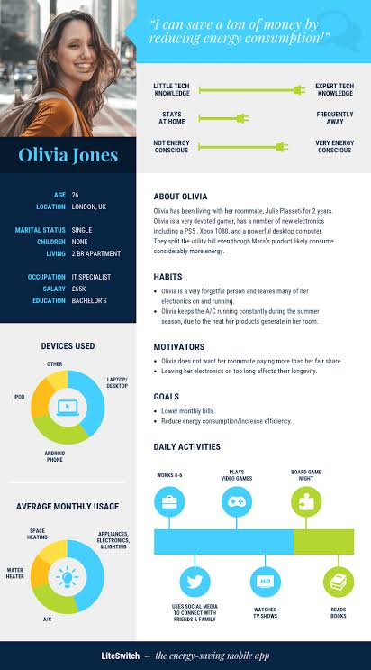

## 1. Primary Target Segments

Haldiram’s appeals to a broad audience, but the key segments include:

### a) Traditional Indian Families

* **Age**: 30–60 years
* **Income Level**: Middle to upper-middle class
* **Location**: Urban and semi-urban areas
* **Buying Motivation**:
  + Preference for authentic Indian flavors
  + Trust in established brands
  + Family consumption during festivals and gatherings

### b) Young Professionals and Millennials

* **Age**: 20–35 years
* **Income Level**: Middle class
* **Location**: Urban areas
* **Buying Motivation**:
  + Convenience (ready-to-eat options)
  + Healthy snack alternatives
  + Quick online ordering (Zomato, Swiggy, Amazon)

### c) Health-Conscious Consumers

* **Age**: 25–45 years
* **Income Level**: Middle to upper-middle class
* **Location**: Urban areas
* **Buying Motivation**:
  + Low-calorie and baked options
  + Reduced salt, sugar, and oil content
  + Nutritional transparency

### d) NRIs and International Consumers

* **Age**: 25–55 years
* **Income Level**: Middle to high income
* **Location**: USA, UK, UAE, Canada, Southeast Asia
* **Buying Motivation**:
  + Nostalgia for Indian flavors
  + Authenticity and premium quality
  + Festival gifting and social events

## 2. Psychographics

* **Values**: Authenticity, tradition, and quality
* **Lifestyle**:
  + Busy professionals looking for quick snacks
  + Families seeking snacks for gatherings and festivals
  + Health-focused consumers balancing taste and nutrition
* **Buying Behavior**:
  + Regular repeat purchases
  + Willing to pay a premium for trusted brands

## 3. Behavioral Insights

* **Preferred Platforms**:
  + E-commerce (Amazon, BigBasket)
  + Food delivery apps (Zomato, Swiggy)
  + Retail stores (modern trade and traditional kirana stores)
* **Consumption Patterns**:
  + High during festive seasons and family events
  + Evening snacks, travel snacks, and quick bites
* **Brand Loyalty**:
  + High loyalty due to product consistency and brand heritage

## 4. Example Buyer Personas

### Persona 1: Rajesh, 42 (Traditional Family ManGoal)

### Goal: Buying snacks for family and festivals

* **Pain Point:** Wants authentic taste but concerned about health
* **Preferred Channel:** Local kirana store and Amazonhorizontal line

### Persona 2: Priya, 28 (Young Professional)

* **Goal:** Quick, tasty snacks for work breaks
* **Pain Point:** Wants healthier options with authentic taste
* **Preferred Channel:** Zomato, Swiggy, and supermarket chains

### Persona 3: Amit, 35 (NRI in the US)

* **Goal:** Finding authentic Indian snacks abroad
* **Pain Point:** Limited product availability locally
* **Preferred Channel:** Amazon, specialty Indian stores

# SEO & keyword rearch

## SEO audit :

:

## 1. SEO Audit

An SEO audit helps identify strengths, weaknesses, and opportunities to improve search visibility.



### a) Technical Audit

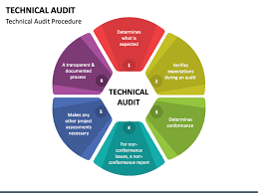

* **Site Speed:**
  + Use **Google PageSpeed Insights** to identify issues affecting loading time.
  + Compress images and enable browser caching.
* **Mobile-Friendliness:**
  + Ensure the site is fully responsive and optimized for different devices.
  + Test using **Google's Mobile-Friendly Test**.
* **Crawlability and Indexing:**
  + Use **Google Search Console** to identify crawl errors and indexing issues.
  + Fix broken links and improve XML sitemap structure.
* **Security:**
  + Ensure the website has an **SSL certificate** (HTTPS).
  + Protect from spam and malware.

### b) On-Page Audit



* **Title Tags and Meta Descriptions:**
  + Ensure titles are under **60 characters** and descriptions under **160 characters**.
  + Include target keywords naturally.
* **Header Structure (H1, H2, H3):**
  + Use a clear hierarchy and include keywords in H1 and H2 tags.
* **Content Quality:**
  + Remove duplicate content.
  + Ensure content is **original, informative, and engaging**.
* **Image Optimization:**
  + Use descriptive **alt text** with keywords.
  + Compress images to improve loading time.

### ✅ c) Off-Page Audit

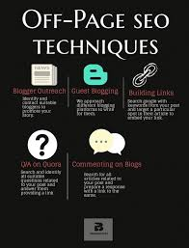

* **Backlink Analysis:**
  + Use tools like **Ahrefs** or **SEMrush** to analyze backlink quality.
  + Remove toxic backlinks and build new high-authority links.
* **Competitor Backlink Analysis:**
  + Identify where competitors are getting backlinks and target similar sources.
* **Social Media and Brand Mentions:**
  + Monitor brand mentions across platforms.
  + Encourage user-generated content and influencer partnerships.

## 2. Keyword Research

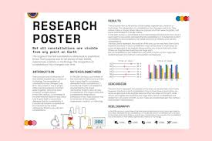

Identify high-performing and low-competition keywords:

### ✅ a) Research Strategy

* **Seed Keywords:**
  + Indian snacks, namkeen, Haldiram sweets
* **Competitor Keywords:**
  + Analyze keywords competitors rank for using **SEMrush** and **Ahrefs**.
* **Long-Tail Keywords:**
  + “Best Indian snacks for Diwali”
  + “Buy Haldiram namkeen online”
  + “Healthy Indian snacks”

### ✅ b) Keyword Types to Target

|  |  |  |
| --- | --- | --- |
| *Keyword* type | Example | Goal |
| Transaction AI | Order Haldiram buhjia online | Drive sales |
| Information AI | Best indian snacks for Diwali | Increase traffic |
| Navigational | Haldiram store near by location | Improve local visibility |
| Branded | Haldiram discount code | Brand loyalty |

### ✅ c) Keyword Research Tools

* **Google Keyword Planner** – Identify search volume and competition.
* **SEMrush** – Find competitor keywords and SERP rankings.
* **Ahrefs** – Analyze backlinks and keyword opportunities.

## 3. On-Page Optimization



After finalizing target keywords, implement on-page improvements:

### ✅ a) URL Structure

* Use clean, descriptive URLs with keywords (e.g., /buy-haldirams-namkeen).
* Avoid unnecessary parameters and special characters.

### ✅ b) Title and Meta Description

* Include the primary keyword at the beginning of the title.
* Use a compelling call-to-action (CTA) in the meta description.

### ✅ c) Content Optimization

* Create **high-quality, keyword-rich content**.
* Add **FAQs** using long-tail keywords to target voice search.
* Use **internal linking** to improve site navigation and authority.

### ✅ d) Image and Video Optimization

* Add descriptive alt text with keywords.
* Compress images and embed videos to increase dwell time.

## 4. Performance Tracking



Use analytics to measure SEO progress:

* **Google Analytics** – Track traffic, bounce rate, and user behavior.
* **Google Search Console** – Monitor ranking changes and indexing issues.
* **SEMrush** – Check keyword positioning and competitor Performance.

# Content Idea's and marketing strategies

Since you're working on a **Comprehensive Digital Marketing project for Haldiram’s**, here are some content ideas and marketing strategies tailored for the brand:

## Content Ideas & Strategy for Haldiram’

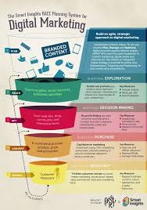

### 1. Engaging Video Content

* **Recipe Videos:** Show innovative ways to use Haldiram’s products in recipes.
* **Behind-the-Scenes:** Factory tours or how traditional recipes are made.
* **Customer Testimonials:** Real experiences of customers enjoying Haldiram’s snacks.
* **Influencer Collaborations:** Partner with food influencers for reviews and recipe challenges.

### 2. Social Media Trends & Engagement

* **Challenges & Contests:** Example: *"Spicy Bhujia Challenge"* or *"Create Your Own Chaat."*
* **Festive-Themed Posts:** Diwali, Holi, Eid, Christmas – custom snack combos & cultural storytelling.
* **UGC (User-Generated Content):** Encourage customers to share their Haldiram’s moments with a branded hashtag.
* **Polls & Quizzes:** “Which Haldiram’s snack matches your personality?”

### 3. Blog & SEO Strategy

* **Snack Pairing Guides:** “Best Haldiram’s Snacks to Pair with Your Evening Tea.”
* **Health & Nutrition Blogs:** Benefits of traditional Indian snacks vs. Western alternatives.
* **Regional Snack Stories:** The history behind iconic snacks like Bhujia, Rasgulla, etc.

### 4. Interactive Content

* **Augmented Reality (AR) Filters:** Instagram/Snapchat filters with Haldiram’s branding.
* **Gamification:** “Spin the Wheel” discounts on the website.

Marketing Strategies for Haldiram’s

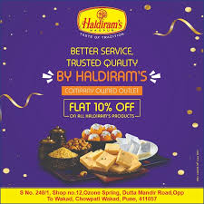

1. Digital Advertising & Paid Campaigns

* **Google Ads & SEO:** Rank for keywords like *"Best Indian Snacks,"* *"Buy Namkeen Online."*
* **Social Media Ads:** Retargeting & personalized ads based on browsing behavior.
* **YouTube Ads:** Short, snackable content featuring crispy bites of Haldiram’s!

### 2. Influencer & Affiliate Marketing

* **Food Bloggers & Vloggers:** Get them to review and create snack-pairing ideas.
* **Micro-Influencer Strategy:** Small, niche influencers for a hyperlocal impact.
* **Affiliate Partnerships:** Collaborate with food delivery platforms like Zomato, Swiggy, Amazon, etc.

### 3. E-commerce & Website Optimization

* **Conversion Rate Optimization (CRO):** Improve UI/UX for better sales.
* **Subscription Boxes:** Monthly snack boxes with exclusive flavors.
* **Bundled Offers:** “Family Snack Pack” or “Festival Special Combos.”

### 4. Offline + Online Integration (Omnichannel Strategy)

* **In-Store Digital QR Codes:** Scan for recipes, contests, and offers.
* **Geo-Targeted Ads:** Personalized offers for customers near Haldiram’s outlets.

### 5. Festive & Seasonal Marketing

* **Limited-Edition Festive Packs:** Holi-special Thandai-flavored snacks, Diwali hampers, etc.
* **CSR Initiatives:** “Buy a Pack, Donate a meal campaigns

# Content Creation and Curation

1. Post Creation Strategy

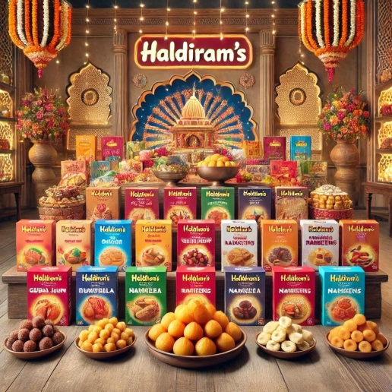

Focus on a mix of content formats to maximize engagement and brand recall:

Content Types:

✅ Recipe-Based Posts: Quick and easy snack recipes using Haldiram’s products.

✅ Storytelling Posts: Highlight Haldiram’s history, ingredient sourcing, and production process.

✅ UGC & Testimonial Posts: Encourage customers to share photos and experiences with Haldiram’s snacks.

✅ Festive-Themed Posts: Promote Haldiram’s products as ideal festive gifts/snacks.

✅ Interactive Content: Polls, Q&A, and “This or That” using Instagram Stories.

Suggested Posting Frequency:

Instagram: 3-4 posts/week + daily stories

Facebook: 3 posts/week

YouTube: 1 video/week

Twitter/X: Daily tweets with trending hashtags

## . Designs & Video Editing Strategy

Design Style:

✔️ Consistent Color Palette: Red, gold, and earthy tones (aligned with Haldiram’s branding).

✔️ Typography: Bold, modern fonts to create a premium feel.

✔️ Logo Placement: Ensure consistent placement of the Haldiram’s logo on all posts.

Video Editing Strategy:

🎯 Format: Vertical for Instagram Reels/Stories and horizontal for YouTube.

🎯 Length:

Reels: 15–30 seconds

YouTube Shorts: 45–60 seconds

Long-form videos: 1–2 minutes

🎯 Editing Style:

Fast cuts for high energy

Use text overlays and call-to-action (CTA) at the end

Background music aligned with the video theme

## 3. Social Media Ad Campaign Strategy

Campaign Objectives:

✅ Brand Awareness: Reach new audiences and increase brand visibility.

✅ Engagement: Encourage likes, shares, and comments.

✅ Conversions: Drive traffic to Haldiram’s e-commerce platform and increase online sales.

Suggested Ad Types:

1. Video Ads: Short recipe videos highlighting product use.

2. Carousel Ads: Multi-slide posts showcasing different Haldiram’s products.

3. Story Ads: “Swipe Up” ads promoting limited-time offers.

4. Retargeting Ads: Target users who interacted with Haldiram’s content but haven’t converted.

Targeting:

🎯 Demographics: 18–45 years, food lovers, Indian snack enthusiasts

🎯 Geography: India, NRI hubs (US, UK, UAE, Canada)

🎯 Interest-Based: Indian cuisine, tea lovers, street food, vegetarian snacks

🎯 Lookalike Audiences: Target users similar to existing customer base

Budget Allocation:

50% for brand awareness (video & carousel ads)

30% for retargeting

20% for engagement and direct conversions4. Email Ideation & Creation Strategy

4 Email Campaign Types:

✅ Welcome Series: “Welcome to the Haldiram’s Family!” – Introduce key product lines and bestsellers.

✅ Festive Promotions: Special offers during Diwali, Holi, Christmas, etc.

✅ Product Recommendations: “Based on your taste, we recommend…”

✅ Cart Abandonment: “Forgot something? Complete your order now!”

✅ Re-engagement Campaign: “We miss you – Here’s 10% off your next order!”

Email Structure:

📧 Subject Line: Short, catchy, and personalized

📧 Header: Eye-catching banner with product imagery

📧 Body:

Introduce offer or message

Include product benefits

Social proof/testimonials

📧 CTA: “Shop Now” or “Explore More”

Email Frequency:

1–2 emails/week

Increase to 3–4 emails/week during festive seasons or special events

# Conclusion



Conclusion for Haldiram’s Digital Marketing Through this comprehensive digital marketing project, we have developed a robust strategy to enhance Haldiram’s brand presence, engage its target audience, and drive sales through various online channels. By leveraging SEO, content creation, social media ad campaigns, and email marketing, we aim to strengthen Haldiram’s market positioning and customer loyalty.

The integration of high-quality designs, compelling video content, and well-optimized posts ensures better brand recall and engagement. Additionally, data-driven insights and performance tracking will help refine strategies for maximum ROI. With consistent execution and adaptation to market trends, Haldiram’s digital presence will continue to thrive, reinforcing its legacy as a leading name in the food industry.